Name: Yaswanthram Ponnada Roll no: CB.EN.U4CSE18243

1)

CREATE TABLE Cust1

(custid varchar2(3) NOT NULL,

Lname varchar2(15),

Fname varchar2(15),

Area varchar2(2),

Phoneno number(8),

CONSTRAINT pk1 PRIMARY KEY(custid));

INSERT INTO Cust1 VALUES ('A01','Byross','Ivan','sa',6125467);

INSERT INTO Cust1 VALUES ('A02','Saitwal','Vandana','mu',5560379);

INSERT INTO Cust1 VALUES ('A03','Jaguste','pramada','da',4563891);

INSERT INTO Cust1 VALUES ('A04','navindgi','basu','ba',6125401');

INSERT INTO Cust1 (custid,Lname,Fname,area)VALUES ('A05','sreedhar','ravi','va');

INSERT INTO Cust1 (custid,Fname,Area,Phoneno)VALUES ('A06','rukmini','gh',5125274);

SELECT \* FROM Cust

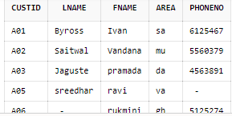

2)

CREATE TABLE Movie1

(mvno number(2) NOT NULL,

title varchar2(25),

movietype varchar2(10),

star varchar2(25),

price number(8,2),

CONSTRAINT pk2 PRIMARY KEY(mvno)

);

INSERT INTO Movie1 VALUES('1','Bloody vengeance','action','Jackie chan',100.00);

INSERT INTO Movie1 VALUES('2','the firm','thriller','Tom crusie',200.00);

INSERT INTO Movie1 VALUES('3','pretty woman','romance','Richard Gere',150.00);

INSERT INTO Movie1 VALUES('4','home alone','comedy','Macualy Culkin',150.45);

INSERT INTO Movie1 VALUES('5','the fugitive','thriller','Harrison Ford',200.00);

INSERT INTO Movie1 VALUES('6','coma','suspence','Michael Dougals',100.00);

INSERT INTO Movie1 VALUES('7','dracula','horror','Gary Oldman',150.67);

INSERT INTO Movie1 VALUES('8','quick change','comedy','Bill Murray',100.00);

INSERT INTO Movie1 VALUES('9','gone with the mind','drama,'Clarke gable'200.00);

INSERT INTO Movie1 VALUES('10','carry on doctor','comedy','Leslie Phillips',100.50);

SELECT \* FROM Movie1

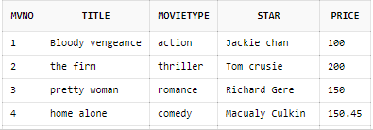

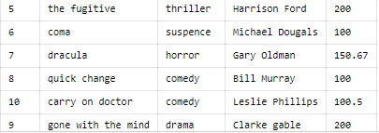

3)

CREATE TABLE Invo(

invno varchar2(3) NOT NULL,

mvno number(2),

custid varchar2(3),

issuedate varchar2(9),

retdate varchar2(9),

CONSTRAINT pk3 PRIMARY KEY(invno),

CONSTRAINT fk FOREIGN KEY(mvno) REFERENCES Movie1(mvno),

CONSTRAINT fk1 FOREIGN KEY(custid) REFERENCES Cust1(custid)

);

INSERT INTO Invo VALUES('I01','4','A01','23-jul-93','25-jul-93');

INSERT INTO Invo VALUES('I02','3','A02','12-aug-93','15-aug-93');

INSERT INTO Invo VALUES('I03','1','A02','15-aug-93','18-aug-93');

INSERT INTO Invo VALUES('I04','6','A03','10-sep-93','13-sep-93');

INSERT INTO Invo VALUES('I05','7','A04','05-aug-93','08-sep-93');

INSERT INTO Invo VALUES('I06','2','A06','18-sep-93','21-sep-93');

INSERT INTO Invo VALUES('I07','9','A05','07-jul-93','10-jul-93');

INSERT INTO Invo VALUES('I08'.'9','A01','11-aug-93','14-aug-93');

INSERT INTO Invo VALUES('I09','5','A03','06-jul-93','09-jul-93');

INSERT INTO Invo VALUES('I10','8','A06','03-sep-93','06-sep-93');

SELECT \* FROM Invo

